For bachelor/master and diploma theses, the title page will be provided by the Examinations Office.

Abstract
Please prepare a short summary of your thesis.
Below you will find information on the general procedure, the content and formal design of your work, citation methods, literature, and organizational aspects. Please use the format of this template as a basis for your own seminar paper or thesis. The structure and exact content are up to you and will be agreed upon during your supervision.
A large number of guides and manuals are now available for academic work and writing. A selection of the most popular works for orientation in the preparation of seminar papers and theses is listed in the bibliography.

Table of Content
Abstract II
Table of Content III
1 Introduction 1
2 Title (1. Level) 1
2.1 Title (2. Level) 1
2.1.1 Title (3. Level) 1
2.1.2 Title (3. Level) 1
2.1.2.1 Title (4. Level) 1
2.1.2.2 Title (4. Level) 1
2.2 Title (2. Level) 1
References 3
Appendix 4
Affidavit 5
The academic paper begins with an outline. This is called the "Table of Contents" and lists the headings of all chapters and (sub)sections with the corresponding page numbers. The outline of the paper should show its logical structure and logically separate and, if necessary, hierarchically organize the individual contents of the paper. In the interest of clarity, it is usually best to avoid subdividing the paper too deeply. Subdivisions using Roman numerals and upper and lower case letters are acceptable.

Introduction

Title (1. Level)
Text Text Text Text Text Text Text Text Text Text Text Text Text Text Text Text Text Text Text Text Text Text Text Text Text Text Text Text Text Text Text Text Text Text Text Text

Title (2. Level)
Text Text Text Text Text Text Text Text Text Text Text Text Text Text Text Text Text Text Text Text Text Text Text Text Text Text Text Text Text Text Text Text Text Text Text Text

Title (3. Level)
Text Text Text Text Text Text Text Text Text Text Text Text Text Text Text Text Text Text Text Text Text Text Text Text Text Text Text Text Text Text Text Text Text Text Text Text

Title (3. Level)
Please always use at least 2 headings on the same level.
Text Text Text Text Text Text Text Text Text Text Text Text Text Text Text Text Text Text Text Text Text Text Text Text Text Text Text Text Text Text Text Text Text Text Text Text

Title (4. Level)
Please limit your outline to a maximum of four levels.

Title (4. Level)
Text Text Text Text Text Text Text Text Text Text Text Text Text Text Text Text Text Text Text Text Text Text Text Text Text Text Text Text Text Text Text Text Text Text Text Text

Title (2. Level)
Text Text Text Text Text Text Text Text Text Text Text Text Text Text Text Text Text Text Text Text Text Text Text Text Text Text Text Text Text Text Text Text Text Text Text Text
Figures and tables may be included in the text to provide a concise and clear supplement or summary of the text. Make sure that all figures (see Figure 1) and tables (see Table 1) are always referenced in the text. Larger figures and more extensive tables should be included in the appendix, if necessary. Figures and tables should be identified by their respective serial number, followed by the title of the figure or table, either at the top or bottom of the figure or table. Any reference to the source should be in the form of a footnote. Please also pay attention to the legibility of graphic elements. Use at least Times New Roman 9pt in tables and figures.
Title column 1 | Title column 2
Text, Text. Text | Text, Text. Text
Text, Text. Text | Text, Text. Text
Text, Text. Text | Text, Text. Text
Text, Text. Text | Text, Text. Text
Text, Text. Text | Text, Text. Text
Table 1: Example table 1

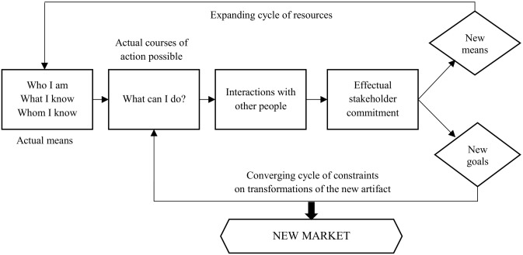
Figure 1: Effectuation process

References
The reference list should include all sources cited directly or indirectly in the text. Literature read but not cited should not be included in the bibliography. A distinction should be made between direct quotations and indirect quotations. In the case of literal quotations, sentences are taken in their entirety from the author. This is indicated by quotation marks. In the case of analogous quotations, only the author's thoughts are quoted. In the text, the quotation is accompanied by a brief reference. Unless otherwise specified by your advisor, the American Psychological Association (APA) citation style will be used.
High quality sources should be used for the literature review. This includes the use of relevant textbooks and handbooks, i.e., basic literature (available at the SULB and via interlibrary loan, if necessary). In addition, relevant academic journals should be used that are ranked in the upper evaluation categories (e.g. A+, A, B, C or 1, 0.7, 0.5, 0.3, 0.2) in the current rankings in the field of business administration (VHB-JOURQUAL ranking of the German Association of University Professors of Business Administration or the Handelsblatt journal ranking for business administration journals).
Brockhaus Sr, R. H. (1980). Risk taking propensity of entrepreneurs. Academy of management Journal, 23(3), 509-520.
Ebster, C. & Stalzer, L. (2008). Wissenschaftliches Arbeiten für Wirtschafts- und Sozialwissenschaftler. 3. Aufl., Universitätsverlag, Wien.
Moroz, P. W., & Hindle, K. (2012). Entrepreneurship as a process: Toward harmonizing multiple perspectives. Entrepreneurship Theory and Practice, 36(4), 781-818.
Schindehutte, M., Morris, M., & Allen, J. (2006). Beyond achievement: Entrepreneurship as extreme experience. Small Business Economics, 27(4-5), 349-368.
Tang, J., Kacmar, K. M. M., & Busenitz, L. (2012). Entrepreneurial alertness in the pursuit of new opportunities. Journal of Business Venturing, 27(1), 77-94.
Töpfer, A. (2010). Erfolgreich Forschen. Ein Leitfaden für Bachelor-, Master-Studierende und Doktoranden. 2.Aufl., Springer, Heidelberg.

Appendix
The appendix contains additions that would be too extensive for the main text and are not directly necessary for its understanding. It may include additional text, digressions, longer examples, and larger or more detailed figures and tables. Each appendix must be referenced at least once in the text section (see Table A-1).

Table A-1: Example table 2
Title column 1 | Title column 2
Text, Text. Text | Text, Text. Text
Text, Text. Text | Text, Text. Text
Text, Text. Text | Text, Text. Text
Text, Text. Text | Text, Text. Text
Text, Text. Text | Text, Text. Text
Text, Text. Text | Text, Text. Text
Text, Text. Text | Text, Text. Text
Text, Text. Text | Text, Text. Text

Affidavit
Please always leave this at the end of the document and sign it.
I hereby declare in lieu of an oath that I have written this thesis independently and without the use of sources and aids other than those specified. Text passages that have been taken literally or analogously from other literature are marked as such. The thesis has not been submitted to any other examination authority in this or any comparable form.

Saarbrücken, XX. month 20XX Signature

Please always cite a source for figures and tables. If you have created these yourself, please indicate this with „Own representation“

